Experiment-11

Procedures

• Create a table with attributes students and marks

• Insert values into the table.

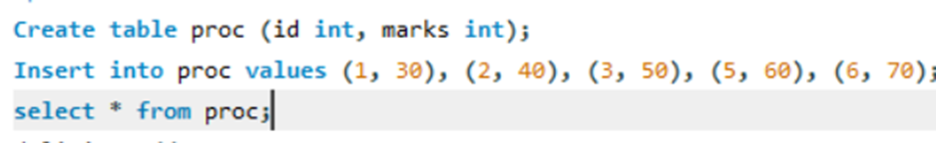

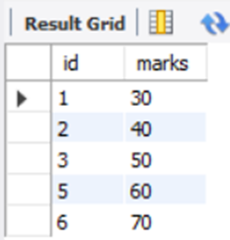

• Create a procedure to get the merit students (marks > 50).

• Create a procedure to get marks of a given id (using in).

